A Crash Course in Being Mortal
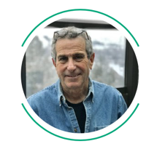
Ira Byock, MD
April 14, 2020 · 5 min. read
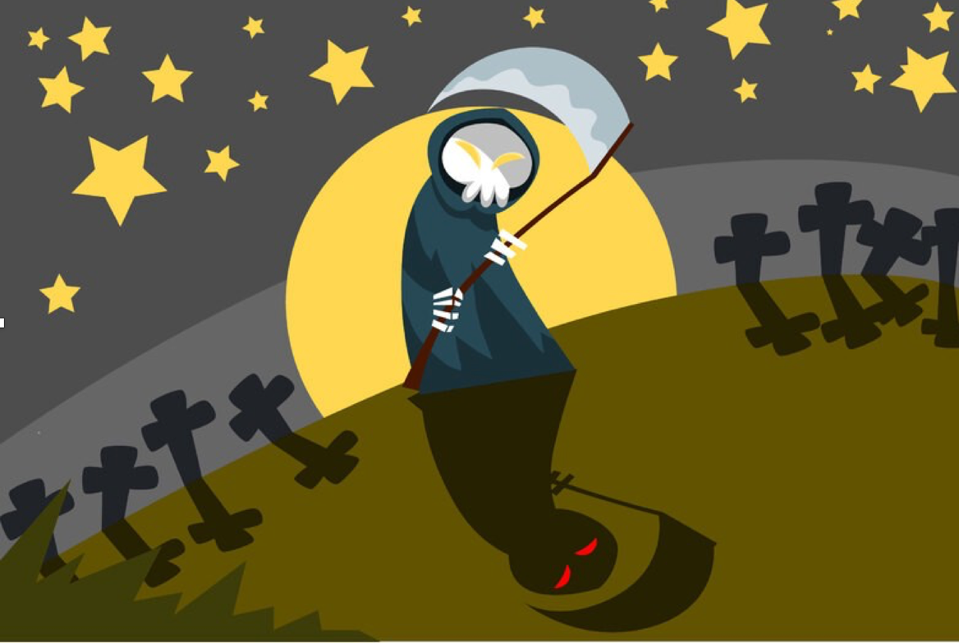
© Mayawizard101 | Stock Free Images

Covid-19 has rudely pulled us into a lucid dream in which we’re enrolled in a course on Contemplating Death we never signed up for. Class has already begun, we’re not prepared, and assignments are coming due. Daunting as the situation is, for those willing to do the work, the lessons may be both enlightening and immediately applicable.

For most of us, death is an abstraction. We know it will find us sometime, somewhere, but that’s all we know. In reality, we live every moment of everyday just a heartbeat — or lethal dysrhythmia, or head-on collision or stray gunshot — away from eternity. Although we can acknowledge all this intellectually, dwelling on a random demise seems senseless, so we don’t. Our busy lives blanket us from remembering how proximate death is.

This semester, Covid-19 has ripped the comforter from our shoulders, leaving us shivering in the cold light of death. Even if we personally survive — and we tell ourselves “I will make it through” — we will not avoid knowing people who die.
It’s no exaggeration to say that Covid-19 is a plague of biblical proportions. This Passover, our eldest family members rather than our first-born children are most at risk. Instead of marking our door frames with the blood of lambs, we are taping up thank you notes for delivery workers who are helping us ward off the Angel of Death. Thankfully, we can draw on human experience with previous plagues, 21st century science, and millennia of wisdom traditions to deal with this global threat.

Because I work in palliative care, I’ve been fielding questions from family and friends — all de facto students of this course — so I’ve drafted this helpful study guide, highlighting key tasks and take-away points in case there’s a pop quiz.

Assignment One: Stay safe. Acceptance of death is over-sold. Dylan Thomas had it right. Why not rage against the dying of the light? After all, we’re all going to be dead a long time. An effective strategy for living fully is to not die prematurely. So stay home, wash your hands, wear masks and try not to touch your face.

Assignment Two: Get your house in order, literally and figuratively. My wife and I have been conducting a life review in the form of spring cleaning our closets of decades-old files, receipts and tchotchkes that no longer have value. We’ve also found old photos and letters that have become priceless and need to be digitally preserved. We’ve finally gotten around to updating the Will we created in 1998. Noticing some emotional loose ends, I’ve been reaching out to old colleagues and friends to check on them and let them know they’re in my thoughts. If death finds me, I want to be right with the world and, mostly importantly, right with the people who matter to me.

Assignment Three: Face your fears. This is by far the most difficult course component, and required preparation for the final exam. Human beings are a self-conscious species, aware that, ultimately, none of us gets out of this life alive. It is worth examining what it is about death that we fear. Non-existence? I’m not so sure. Consider, is it scary to contemplate where you were before conception? I’ve yet to meet anyone who answered Yes to that question. More likely, it is the loss of having been that evokes death anxiety.

When meditation teachers guide students in contemplating non-existence — staying present without recoiling — death’s menacing face commonly dissolves into sadness. The prospect of endless separation from the people we love occupies the core of what we dread about being dead.

If that’s so, the pathophysiology of Covid-19 seems designed to realize our worst nightmares. Patients who become short of breath with this infection may deteriorate rapidly and sometimes do better if rapidly sedated, intubated and mechanically ventilated. Twelve to 16 days or more of intensive care and ventilatory support may be needed for people to improve — or to know that they cannot. But the separations are immediate. The few minutes between a clinical decision to intubate someone and sliding a tube through their vocal cords, may be a patient’s and family’s final chance to communicate.

I’ve learned from people of my grandparents’ and parents’ generations who lost lovers, friends and relatives during WWI and WWII, that grief is profound and at times unbearable, but that sorrow can be endured. Those who were resilient seemed to accept grief as the cost of love. Tennyson’s familiar lines from In Memoriam A.H.H. are apt:
’Tis better to have loved and lost
Than never to have loved at all.
They taught me that without denying sorrow, it is possible to feel gratitude and joy.

Facing one’s deepest fears can bring new freedom. Culturally, this is a WTF moment, which a coworker’s mother thinks stands for Well, that’s fantastic! Unwanted as it is, this crisis provides an opportunity to take stock and reinvest in what matters most. Students take note: This is the main thesis of the course.
If I were giving society an interim grade, I’d say we’re collectively off to a good start.

There is so much creative energy going into building and maintaining human connections despite our need for physical distancing. Working in health care, I’ve been impressed by how quickly we’ve pivoted to using video platforms to perform clinical visits which include sensitive conversations and poignant family meetings. For hospital-based clinicians, the most distressing aspect of this pandemic is the need to separate seriously ill patients from their families. While there is no adequate substitute for human touch, family visiting has now gone virtual with surprisingly satisfying results. Families gathered in their homes across states and countries are meeting together in gallery views to visit with sick loved ones. They’re sharing stories of cherished events, gently teasing one another, affectionately forgiving past misdeeds, and honoring and celebrating the person whose life may be coming to a close.

Non-clinical workplaces also have gone virtual. In addition to project-related meetings, the team I lead is enjoying video lunch socials, as well as occasional after-work happy hours during which we lift glasses of wine or cocktails — my preferred drink is a Quarantini — while catching up and kibitzing with one another.
Homebound families are devising ways of staying connected with relatives. Grandparents are reading to young children over the phone, FaceTime, Skype or Zoom and figuring out how to use video white boards to play tic-tac-toe, math puzzles, word games and squiggles. Online communities are flourishing. Faith communities are holding online services. Book clubs and pet groups are meeting by video. Musicians are giving free concerts, and poets, readings. At times it seems we are more connected than ever.

Songwriter Graham Nash once opined: “Life is not perfect; it never will be… you have to open your heart to what the world can show you. Sometimes it’s terrifying and sometimes it’s incredibly beautiful. And I’ll take both, thanks.”

If we apply the lessons that this pandemic has to teach, we can ace this course and emerge able to look mortal life in the face and declare, Well, that’s fantastic!

It really is.
Ira Byock, MD is a palliative care physician and chief medical officer of the Institute for Human Caring. His books include Dying Well and The Best Care Possible.

